ASSIGNMENT 4

Ultrasonic sensor simulation in Wokwi

Question :

Write a code and connections in wokwi for the ultrasonic sensor. Whenever the distance is less than 100cms send an “Alert” to IBM cloud and display in the device recent events.

Code:

#include <WiFi.h>//library for wifi

#include <PubSubClient.h>//library for MQtt

#define ECHO_PIN 2

#define TRIG_PIN 4

#define LED 5

//-------credentials of IBM Accounts------

#define ORG "73q3u4"//IBM ORGANITION ID

#define DEVICE_TYPE "Harini"//Device type mentioned in ibm watson IOT Platform

#define DEVICE_ID "07112001"//Device ID mentioned in ibm watson IOT Platform

#define TOKEN "6z2YJbzbD@SldDeK3B"     //Token

//-------- Customise the above values --------

char server[] = ORG ".messaging.internetofthings.ibmcloud.com";// Server Name

char publishTopic[] = "iot-2/evt/Data/fmt/json";// topic name and type of event perform and format in which data to be send

char subscribetopic[] = "iot-2/cmd/test/fmt/String";// cmd  REPRESENT command type AND COMMAND IS TEST OF FORMAT STRING

char authMethod[] = "use-token-auth";// authentication method

char token[] = TOKEN;

char clientId[] = "d:" ORG ":" DEVICE_TYPE ":" DEVICE_ID;//client id

//-----------------------------------------

WiFiClient wifiClient; // creating the instance for wificlient

PubSubClient client(server, 1883,wifiClient); //calling the predefined client id by passing parameter like server id,portand wificredential

void setup()// configureing the ESP32

{

**Serial**.begin(115200);

  pinMode(TRIG_PIN, OUTPUT);

  pinMode(ECHO_PIN, INPUT);

  pinMode(LED,OUTPUT);

  delay(10);

**Serial**.println();

  wificonnect();

  mqttconnect();

}

float readDistanceCM() {

  digitalWrite(TRIG_PIN, LOW);

  delayMicroseconds(2);

  digitalWrite(TRIG_PIN, HIGH);

  delayMicroseconds(10);

  digitalWrite(TRIG_PIN, LOW);

  int duration = pulseIn(ECHO_PIN, HIGH);

  return duration * 0.034 / 2;

}

void loop()// Recursive Function

{

  float distance = readDistanceCM();

  bool isNearby = distance < 100;

  digitalWrite(LED, isNearby);

**Serial**.print("Measured distance: ");

**Serial**.println(distance);

  delay(100);

  if (isNearby == 1){

  PublishData(distance);

  }

  delay(1000);

  if (!client.loop()) {

    mqttconnect();

  }

}

/*.....................................retrieving to Cloud...............................*/

void PublishData(float distance) {

  mqttconnect();//function call for connecting to ibm

  /*

     creating the String in in form JSon to update the data to ibm cloud

  */

  String payload = "{\"Alert\":""\"";

  payload += distance;

  payload += " is less than 100cms\"";

  payload += "}";

**Serial**.print("Sending payload: ");

**Serial**.println(payload);

  if (client.publish(publishTopic, (char*) payload.c_str())) {

**Serial**.println("Publish ok");// if it sucessfully upload data on the cloud then it will print publish ok in Serial monitor or else it will print publish failed

  } else {

**Serial**.println("Publish failed");

  }

}

void mqttconnect() {

  if (!client.connected()) {

**Serial**.print("Reconnecting client to ");

**Serial**.println(server);

    while (!!!client.connect(clientId, authMethod, token)) {

**Serial**.print(".");

      delay(500);

    }

     initManagedDevice();

**Serial**.println();

  }

}

void wificonnect() //function defination for wificonnect

{

**Serial**.println();

**Serial**.print("Connecting to ");

  WiFi.begin("Wokwi-GUEST", "", 6);//passing the wifi credentials to establish the connection

  while (WiFi.status() != WL_CONNECTED) {

    delay(500);

**Serial**.print(".");

  }

**Serial**.println("");

**Serial**.println("WiFi connected");

**Serial**.println("IP address: ");

**Serial**.println(WiFi.localIP());

}

void initManagedDevice() {

  if (client.subscribe(subscribetopic)) {

**Serial**.println((subscribetopic));

**Serial**.println("subscribe to cmd OK");

  } else {

**Serial**.println("subscribe to cmd FAILED");

  }

}

Diagram.json:

{

  "version": 1,

  "author": "harini",

  "editor": "wokwi",

  "parts": [

    { "type": "wokwi-esp32-devkit-v1", "id": "esp", "top": -17.57, "left": -116.71, "attrs": {} },

    {

      "type": "wokwi-led",

      "id": "led1",

      "top": -16.04,

      "left": 21.83,

      "attrs": { "color": "red" }

    },

    {

      "type": "wokwi-resistor",

      "id": "r1",

      "top": 41.63,

      "left": 48.17,

      "attrs": { "value": "1000" }

    },

    {

      "type": "wokwi-hc-sr04",

      "id": "ultrasonic1",

      "top": -69.2,

      "left": 151.85,

      "attrs": { "distance": "83" }

    }

  ],

  "connections": [

    [ "esp:TX0", "$serialMonitor:RX", "", [] ],

    [ "esp:RX0", "$serialMonitor:TX", "", [] ],

    [ "led1:A", "r1:1", "green", [ "v0" ] ],

    [ "r1:2", "esp:D5", "green", [ "v0" ] ],

    [ "led1:C", "esp:GND.1", "black", [ "v0" ] ],

    [ "esp:D4", "ultrasonic1:TRIG", "green", [ "h246.49", "v-79.83" ] ],

    [ "esp:D2", "ultrasonic1:ECHO", "green", [ "h0" ] ],

    [ "esp:GND.1", "ultrasonic1:GND", "black", [ "h262.72", "v-104.77" ] ],

    [ "ultrasonic1:VCC", "esp:3V3", "red", [ "v0" ] ]

  ]

}

Wokwi simulation link:

<https://wokwi.com/projects/347836298718872148>

Circuit Diagram:

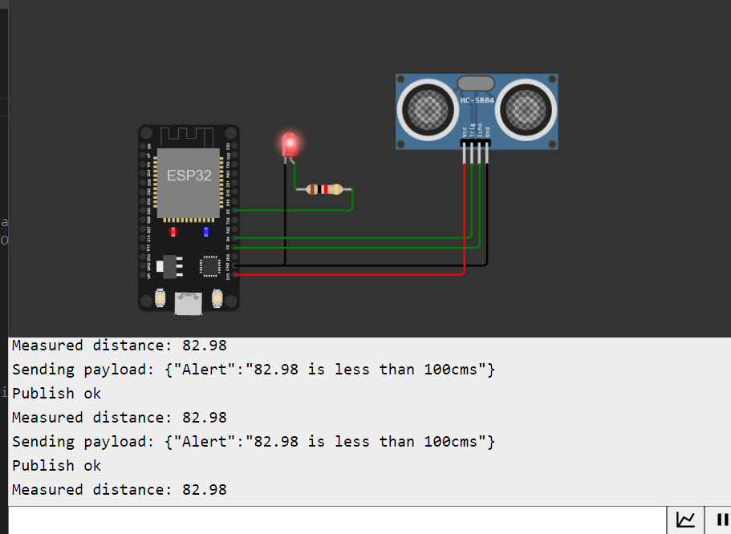

IBM cloud output:

